**1. A set of relations mapped from E-R diagram (3NF)**

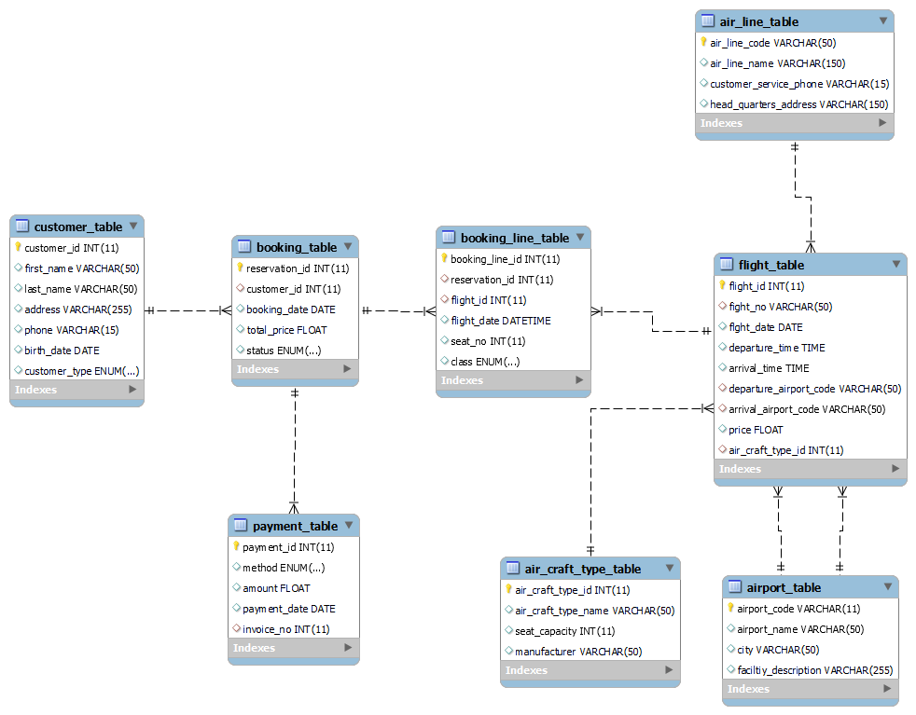

**Normalization**

Normalization is the process in which data is structured in the relational database. It helps to reduce redundancy in the data tables. Data Integrity and Data Redundancy are main operation on the database in the process of the normalization.

Normalisation

1. It helps in data integrity it means all tables are consistent and satisfy constraint present in the table.
2. It helps in reducing data redundancy by use of primary key and foreign key.

There are basically five types of normalizations:

* First Normal Form
* Second Normal Form
* Third Normal Form
* BCNF
* Fourth Normal Form etc.

**Set of Relations**

|  |  |  |  |  |
| --- | --- | --- | --- | --- |
| Sri | PK Table Name | Primary Key | FK Table Name | Foreign Key |
| 1 | Customer Table | Customer id | Booking Table | Customer id |
| 2 | Booking Table | Reservation id | Payment Table | Reservation Id |
| 3 | Booking Table | Reservation id | Booking Line Table | Reservation Id |
| 4 | Flight Table | Flight id | Booking Table | Flight id |
| 5 | Air Line Table | Airline code | Flight table | Flight no |
| 6 | Airport table | Airport code | Flight Table | Departure airport code |
| 7 | Airport Table | Airport Code | Flight Table | Arrival airport code |
| 8 | Air craft type table | Air craft type id | Flight table | Air craft type id |

**Example**

|  |  |  |
| --- | --- | --- |
| Sri No | Column Name | Constraint |
| 1 | Airline code | Primary Key attribute |
| 2 | Airline Name | Non -prime attribute |
| 3 | Customer Service Phone | Non -prime attribute |
| 4 | Headquarters Address | Non -prime attribute |

Following are functional dependencies:

1. Airline Name is fully dependent on Airline Code

2. Customer Service Phone is fully dependent on Airline Code

3. Headquarters Address is fully dependent on Airline Code

Above table is normalized in three forms of normalization

**First Form of Normalization (1NF)**: In this rule of normalisation the values in column should have unique values, atomic valued columns, values in the column should be of same type. In this Primary key is used to make values unique.

**Second Form of Normalization(2NF)**: In Second Form of Normalization there should be First Form of normalization and there is no partial dependency. AirlineName is not may not be unique for every airline. It may be possible that two different airports have same name. So there should be single valued candidate key i.e. AirlineCode.

**Third Form of Normalization(3NF)**: In Third Form of Normalization, it doesn’t contain transitive dependency. It needs to fulfil all requirements of First, Second and Third Form of Normalization.

|  |  |  |
| --- | --- | --- |
| Sri No | Column Name | Constraint |
| 1 | Reservation Id | Primary Key attribute |
| 2 | Booking Date | Non -prime attribute |
| 3 | Total Price | Non -prime attribute |
| 4 | Customer id | Non -prime attribute |

Following are functional dependencies:

1. Booking Date is fully dependent on Reservation Id

2. Total Price Phone is fully dependent on Reservation Id

3. Customer id is fully dependent on Reservation Id

Above table is normalized in three forms of normalization

**First Form of Normalization(INF)**: In First Form of Normalization there is one primary key of the table i.e. ReservationID. BookingDate will be stored against one ReservationID for each booking. With use of primary key, there is no redundancy in the table. Values in table are unique values.

**Second Form of Normalization(2NF)**: In Second Form of Normalization there should be First Form of normalization and there is no partial dependency. As BookingDate is not unique for every customer booking. TotalPrice can’t be unique may many customer booking has same TotalPrice. One Customer can have multiple bookings So CustomerID is also not unique is this table. So there should be single valued candidate key i.e. ReservationID.

**Third Form of Normalization(3NF)**: In Third Form of Normalization it doesn’t contain transitive dependency. It needs to fulfil all requirements of First, Second and Third Form of Normalization.

**Implementation Report**

**Joins**

Use of joins in query is new concept for me in this I have learnt how use joins

**Sub query**

Use of sub query in outer query is new concept for me in this I have learnt how use sub query inside the outer query and match outer query result with the sub query result.

**Relations Models and Normalization**

Implantation of Normalization which includes 1NF, 2NF, 3NF which helps me to learn various relations as we like one to many, many to many, with help of normalization I reduce the redundancy. Proper implementation of Primary and Foreign Keys Concept which allows us to maintain the reference integration. It helps us to keep our database secure.

**Complex Requirement**

Design of report from the query is complex for me. It’s for the first time I am trying to create report from the query. I have learnt I feel it interesting to create report. As we need set colours, fonts etc.